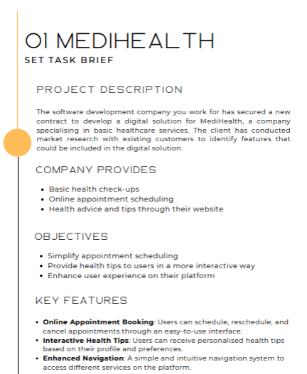

Proposal for MediHealth
1. Project Overview
MediHealth aims to modernise how users access basic healthcare services by introducing a streamlined digital platform. The goal is to simplify appointment scheduling, improve access to trustworthy health tips, and create a smoother user experience through clear navigation and interactive features. The upgraded system will reduce booking difficulties, increase user engagement, and support better access to everyday health advice.
To achieve this, MediHealth plans to enhance their existing service with features that allow users to schedule, reschedule, and manage appointments efficiently while also receiving personalised healthcare guidance online.
The proposed digital solution will include:
• Online Appointment Booking
Lets users schedule, reschedule, and cancel appointments easily through a simple interface.
• Interactive Health Tips
Provides personalised health tips and advice tailored to user profiles and preferences.
• Enhanced Navigation
A clear and intuitive navigation system for accessing different healthcare services on the platform.
These features directly support MediHealth’s mission of improving user experience and increasing accessibility to everyday health services.

2. Problems Identified
Problem 1 – Complicated or Inconvenient Appointment Scheduling
Users struggle to book, change, or cancel appointments quickly, which leads to delays and frustration.
Problem 2 – Health Advice Lacks Personalisation
Current health tips are generalised and do not adapt to users' needs, age ranges, or interests, making advice less engaging.
Problem 3 – Poor Navigation and User Experience
The current platform layout makes it difficult for users to find key services, causing confusion and reduced engagement.

3. Proposed Solutions
Solution to Problem 1 – Online Appointment Booking
A user-friendly tool that allows individuals to schedule, update, or cancel appointments easily, with email/SMS confirmations and reminders.
Solution to Problem 2 – Interactive Health Tips
A system that gives personalised health guidance based on user profiles, selected preferences, and browsing behaviour.
Solution to Problem 3 – Enhanced Navigation
A simplified and well-structured navigation system that helps users find health check-ups, advice, and bookings quickly.

4. Decomposition of Solutions
Online Appointment Booking
The booking tool collects information such as preferred dates, times, and the type of health check-up required.
Users can view available slots, choose a preferred appointment, and receive instant confirmation.
They can also reschedule or cancel their appointment at any time, with the system automatically updating availability.
Interactive Health Tips
The system gathers user preferences, health interests, and demographic details.
It then provides personalised tips, articles, and advice tailored to the user’s needs.
Users can save tips, filter categories, or update their profile to improve relevance.
Enhanced Navigation
The navigation structure places key features (appointments, health tips, account settings) in easy-to-reach areas.
Clear menu categories, icons, and consistent page layouts improve accessibility.
A built-in search bar helps users quickly find the services or advice they need.

5. Client and User Needs
MediHealth’s main goals are to simplify appointments, deliver helpful health tips more effectively, and improve the user experience on their platform.
• New users need simple instructions, clear layouts, and easy-to-follow booking steps.
• Busy users need fast navigation and a quick appointment system.
• Users with accessibility needs require screen reader compatibility, strong contrast, and keyboard navigation.
• Health-conscious users need personalised, reliable health advice tailored to them.
To meet these needs, the platform must include an efficient booking system, personalised health tips, and enhanced navigation.
These features will improve usability, support long-term engagement, and promote healthier routines.

6. Mitigating Potential Risks
Online Appointment Booking
Validation checks will prevent invalid date or time entries. Automated testing will reduce the chance of scheduling errors.
Secure APIs will protect appointment data.
User Accounts
Passwords and personal data will be encrypted. MFA, secure resets, and login alerts will prevent unauthorised access.
Interactive Health Tips
Health information will be approved by certified professionals to avoid misinformation.
Outdated advice will be reviewed and updated regularly.
Enhanced Navigation
Usability testing will identify confusing layouts early. WCAG guidelines will be followed to ensure accessibility.
Technical Reliability
Cloud hosting, autoscaling, and failover systems will prevent downtime. Regular backups will protect all stored data.

7. Security & Compliance Risks
Security Features
Encryption will protect all stored and transmitted data.
Multi-Factor Authentication (MFA), RBAC controls, and routine system audits will enhance safety.
The platform will follow GDPR rules and meet WCAG accessibility standards.
Legal Requirements
• Equality Act 2010 – requires digital accessibility for all users.
• Consumer Rights Act 2015 – ensures health information is accurate and not misleading.
• GDPR – governs data storage, consent, and handling of personal medical information.
• Copyright laws – apply to third-party health articles, images, and resources.

8. System Requirements
Functional Requirements
• Secure user login with profile management
• Online Appointment Booking with rescheduling and cancellation
• Personalised Interactive Health Tips
• Clear navigation menus and search tools
• Automated notifications for upcoming appointments
Non-Functional Requirements
• 99.9% uptime
• High security and strong encryption
• Fast performance and responsive design
• Scalable infrastructure for growing user numbers
• Full WCAG accessibility compliance

9. Key Performance Indicators (KPIs)
• Appointment Success Rate: 95% of bookings completed without errors
• User Engagement: 30% increase in interactions with health tips
• Navigation Efficiency: Users should find key pages within 3 clicks
• Page Load Time: Under 2.5 seconds on all major pages
• System Uptime: 99.9% availability
• User Retention: 15% increase within six months

10. User Acceptance Criteria (UAC)
Online Appointment Booking
Users must be able to book, reschedule, or cancel smoothly, and receive accurate reminders.
Interactive Health Tips
Tips must be relevant to user preferences, load quickly, and allow saving or filtering.
Enhanced Navigation
Users must reach core features within three taps, with consistent layouts and full screen-reader support.

